**PRACTICAL NO:3**

**Q1) Write a program to Implement DES Algorithm.**

**CODE:**

import java.util.Scanner;

import javax.crypto.*;

public class DES {

Cipher encipher,dcipher;

public static void main(String args[])

{

System.out.println("Enter any String:");

Scanner sc=new Scanner(System.in);

String input=sc.nextLine();

try

{

KeyGenerator k=KeyGenerator.getInstance("DES");

SecretKey key=k.generateKey();

DES en=new DES(key);

String ct=en.encrypt(input);

String decrypted=en.decrypt(ct);

System.out.println("Original string is:"+input);

System.out.println("Encrypted string is:"+ct);

System.out.println("Decrypted string is:"+decrypted);

}

catch(Exception e){

System.out.println(e);

}

}

public DES(SecretKey key)

{

try

{

encipher=Cipher.getInstance("DES");

encipher.init(Cipher.ENCRYPT_MODE,key);

dcipher=Cipher.getInstance("DES");

dcipher.init(Cipher.DECRYPT_MODE,key);

}

catch(Exception e)

{

System.out.println(e);

}

}

public String encrypt(String str)

{

try {

byte[] b=str.getBytes();

byte[] enc=encipher.doFinal(b);

return new String(enc);

} catch (Exception e) {

System.out.println(e);

// TODO: handle exception

}

return null;

}

public String decrypt(String str)

{

try{

byte[] b=str.getBytes();

byte[] dec=dcipher.doFinal(b);

return new String(dec);

}

catch(Exception e){

System.out.println(e);

}

return null;

}

}

OUTPUT:

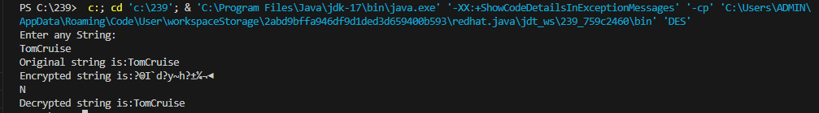

Q2)Write a program to Implement AES algorithm.

CODE:

import java.util.Scanner;

import javax.crypto.*;

public class AES {

Cipher encipher,dcipher;

public static void main(String args[])

{

System.out.println("Enter any String:");

Scanner sc=new Scanner(System.in);

String input=sc.nextLine();

try

{

KeyGenerator k=KeyGenerator.getInstance("AES");

SecretKey key=k.generateKey();

AES en=new AES(key);

String ct=en.encrypt(input);

String decrypted=en.decrypt(ct);

System.out.println("Original string is:"+input);

System.out.println("Encrypted string is:"+ct);

System.out.println("Decrypted string is:"+decrypted);

}

catch(Exception e){

System.out.println(e);

}

}

public AES(SecretKey key)

{

try

{

encipher=Cipher.getInstance("AES");

encipher.init(Cipher.ENCRYPT_MODE,key);

dcipher=Cipher.getInstance("AES");

dcipher.init(Cipher.DECRYPT_MODE,key);

}

catch(Exception e)

{

System.out.println(e);

}

}

public String encrypt(String str)

{

try {

byte[] b=str.getBytes();

byte[] enc=encipher.doFinal(b);

return new String(enc);

} catch (Exception e) {

System.out.println(e);

}

return null;

}

public String decrypt(String str)

{

try{

byte[] b=str.getBytes();

byte[] dec=dcipher.doFinal(b);

return new String(dec);

}

catch(Exception e){

System.out.println(e);

}

return null;

}

}

OUTPUT:  
